**ISO 20022**

Securities Financing Transaction Reporting

**Message Definition Report** **- Part 1**

1. Approved by the Securities SEG on the 25th of November 2019
2. Updates approved by the Securities SEG on the 28th of June 2021

October 2021

Table of contents

1. Introduction 6

1.1 Terms and definitions 6

1.2 Glossary 6

1.3 Document Scope and Objectives 7

1.4 References 8

2. Scope and Functionality 9

2.1 Background 9

2.2 Scope 9

2.3 Groups of MessageDefinitions and Functionality 9

2.3.1 SFT MessageDefinitions 9

2.3.2 Reconciliation MessageDefinitions 10

2.3.3 Query report 10

2.3.4 Position set report 10

2.3.5 Other Message Definitions 10

3. BusinessRoles and Participants 11

3.1 Participants and BusinessRoles Definition 11

4. BusinessProcess Description 13

4.1 BusinessProcess 13

5. Description of BusinessActivities 15

5.2. Transaction reporting. 16

5.2.1 SFT reporting overview 16

5.2.2. SFT reconciliation 18

5.2.3 Reporting of the amendments to the SFT 19

5.2.4. TR reporting and publication. 20

5.2.5 SFT aggregated data publication 21

5.2.6. Data dissemination based on the queries. 22

5.2.7. SFT position data aggregation 23

6. BusinessTransactions 24

6.1 SFT Reporting 24

6.2 SFT Reconciliation 25

7. Examples 27

7.1 SFT Status Advice 27

7.1.1 auth.031.001.01 27

7.2 SFT Report 27

7.2.1 auth.052.001.02 27

7.3 SFT Report Margin Data 32

7.3.1 auth.070.001.02 32

7.4 SFT Report Margin State Data 34

7.4.1 auth.085.001.02 34

7.5 SFT Report Reuse Data 35

7.5.1 auth.071.001.02 35

7.6 SFT State Report Reuse Data 37

7.6.1 auth.086.001.02 37

7.7 SFT Report Pairing Request 38

7.7.1 auth.078.001.02 38

7.8 SFT Matching Request 39

7.8.1 auth.079.001.02 39

7.9 SFT Report Reconciliation Status Advice 44

7.9.1 auth.080.001.02 44

7.10 SFT Missing Collaterals 45

7.10.1 auth.083.001.02 45

7.11 SFT Rejection Reason Report 46

7.11.1 auth.084.001.02 46

7.12 SFT Transaction Query Report 48

7.12.1 auth.094.001.02 48

7.13 SFT Position Set Report 50

7.13.1 auth.105.001.02 50

8. Revision Record 53

**Preliminary note:**

The Message Definition Report (MDR) is made of three parts:

* **MDR - Part 1** describes the contextual background required to understand the functionality of the proposed message set. Part 1 is produced by the submitting organisation that developed or maintained the message set in line with a MDR Part1 template provided by the ISO 20022 Registration Authority (RA) on [www.iso20022.org](http://www.iso20022.org)
* **MDR – Part 2** is the detailed description of each message definition of the message set. Part 2 is produced by the RA using the model developed by the submitting organisation.
* **MDR – Part 3** is an extract of the ISO 20022 Business Model describing the business concepts used in the message set. Part 3 is an Excel document produced by the RA.

# Introduction

## Terms and definitions

The following terms are reserved words defined in ISO 20022 – Part1. When used in this document, they will follow the UpperCamelCase notation.

|  |  |
| --- | --- |
| Term | Definition |
| BusinessRole | functional role played by a business actor in a particular BusinessProcess or BusinessTransaction |
| Participant | involvement of a BusinessRole in a BusinessTransaction |
| BusinessProcess | unrealized definition of the business activities undertaken by BusinessRoles within a BusinessArea whereby each BusinessProcess fulfils one type of business activity and whereby a BusinessProcess may include and extend other BusinessProcesses |
| BusinessTransaction | particular solution that meets the communication requirements and the interaction requirements of a particular BusinessProcess and BusinessArea |
| MessageDefinition | formal description of the structure of a MessageInstance |

## Glossary

**Acronyms/abbreviations**

|  |  |
| --- | --- |
| Acronym | Definition |
| AIF | Alternative Investment Fund |
| BAH | Business Application Header |
| BIC | Business Identifier Codes (ISO 9362) |
| CI | Credit Institution |
| CA | Competent Authority |
| CCP | Central Counterparty |
| CET | Central European Time |
| CSD | Central Securities Depository |
| EEA | European Economic Area |
| EoD | End of Day |
| ERR | Entity Responsible for Reporting |
| ESMA | European Securities and Markets Authority |
| EU | European Union |
| IF | Investment Firm |
| ITS | Implementation Technical Standard |
| IU | Insurance Undertaking |
| LEI | Legal Entity Identifier (ISO 17442) |
| MDR | Message Definition Report |
| MIC | Market Identifier Code |
| MP | Market Participants |
| ORI | Occupational Retirement Institution |
| OU | Other Undertakings |
| RE | Reporting Entity |
| RSE | Report Submitting Entity |
| RTS | Regulatory Technical Standard |
| SEG | Standards Evaluation Group |
| SFT | Securities Financing Transaction |
| SFTR | Securities Financing Transaction Regulation |
| SWIFT | Society for Worldwide Interbank Financial Telecommunication |
| TCE | Third Country Entity |
| TR | Trade Repository |
| UCIT | Undertakings for Collective Investment in Transfarable |

## Document Scope and Objectives

This document is the first part of the ISO 20022 Message Definition Report (MDR) that describes the BusinessTransactions and underlying message set. For the sake of completeness, the document may also describe BusinessActivities that are not in the scope of the project.

This document sets:

* The BusinessProcess scope (business processes addressed or impacted by the project)
* The BusinessRoles involved in these BusinessProcesses

The main objectives of this document are:

* To explain what BusinessProcesses and BusinessActivities these MessageDefinitions have addressed
* To give a high level description of BusinessProcesses and the associated BusinessRoles
* To document the BusinessTransactions and their Participants (sequence diagrams)
* To list the MessageDefinitions

## References

| Document | Version | Date | Author |
| --- | --- | --- | --- |
| [Regulation (EU) 2015/2365 of the European Parliament and of the Council of 25 November 2015 on transparency of securities financing transactions and of reuse and amending Regulation (EU) No 648/2012](https://eur-lex.europa.eu/legal-content/EN/TXT/PDF/?uri=CELEX:32015R2365&from=EN) | Final | 2015-12-23 | EU Parliament |
| [Business Justification](https://www.iso20022.org/submission-status/741/download) document (BJ 119) | Final | 2016-10-17 | ESMA |
| [Commission Delegated Regulation (EU) 2019/356 of 13 December 2018 supplementing Regulation (EU) 2015/2365 of the European Parliament and of the Council with regard to regulatory technical standards specifying the details of securities financing transactions (SFTs) to be reported to trade repositories](https://eur-lex.europa.eu/legal-content/EN/TXT/PDF/?uri=CELEX:32019R0356&from=EN) | Final | 2019-03-22 | EU Parliament |
| [Commission Implementing Regulation (EU) 2019/363 of 13 December 2018 laying down implementing technical standards with regard to the format and frequency of reports on the details of securities financing transactions (SFTs) to trade repositories in accordance with Regulation (EU) 2015/2365 of the European Parliament and of the Council and amending Commission Implementing Regulation (EU) No 1247/2012 with regard to the use of reporting codes in the reporting of derivative contracts](https://eur-lex.europa.eu/legal-content/EN/TXT/PDF/?uri=CELEX:32019R0363&from=EN) | Final | 2019-03-22 | EU Parliament |
| [Final report: Guidelines on reporting under Articles 4 and 12 SFTR](https://www.esma.europa.eu/sites/default/files/library/esma70-151-2703_final_report_-_guidelines_on_reporting_under_sftr.pdf) | Final | 2020-01-06 | ESMA |
| [Validation rules under SFTR](https://www.esma.europa.eu/sites/default/files/esma70-151-1019_sftr_validation_rules.xlsx) | Final | 2020-01-06 | ESMA |
| [Draft Guidelines on calculation of positions in SFTs by Trade Repositories](https://www.esma.europa.eu/sites/default/files/library/esma74-362-608_guidelines_on_calculation_of_positions_in_sfts_by_trade_repositories.pdf) | Draft / Consultation Paper | 2020-07-09 | ESMA |
| [Questions and Answers on SFTR data reporting](https://www.esma.europa.eu/sites/default/files/library/esma74-362-893_qas_on_sftr_data_reporting.pdf) | Final | 2021-05-20 | ESMA |
| Final report and [Guidelines on calculation](https://www.esma.europa.eu/sites/default/files/library/esma70-151-2838_guidelines_on_reporting_under_sftr.pdf) of positions in SFTs by Trade Repositories | Final | 2021-05-20 | ESMA |

# Scope and Functionality

## Background

This Message Definition Report covers a set of thirteen (13) ISO 20022 MessageDefinitions developed by European Securities and Markets Authority in close collaboration with SWIFT and approved by the Securities SEG on the 25th of November 2019. Following this the updated version was approved by the Securities SEG on the 28th of June 2021.

These MessageDefinitions are specifically designed to support the reporting transactions, the reconciliation process and calculation of aggregated positions on SFT transactions. The relevant messages will be submitted by the financial and non-financial institution being counterparties to SFT transactions or other entities authorized to submit such reports and the Trade Repositories. This data will be used to support :

* Reporting of the SFT data to the TRs
* Verification of completeness and correctness of the SFT data by the TRs
* Reconciliation of the collected data between the TRs
* Publication of the aggregates
* Facilitating authorities with access to the collected data

## Scope

With the coming into force of SFTR, market participants are required to report to Trade Repositories all data pertaining to the securities financing transactions. In particular, reporting is related to Buy Sell Back, Repurchase, Securities Lending and Margin Lending transactions. All data collected by the Trade Repositiores will be made available to the National Competent Authorities through a dedicatated system established by ESMA (the Access to Trade Repositories System – TRACE). Moreover, certain subset of the collected data will be made publically available.

Based on the large volumes of data as well as the number and range of institutions that will generate and submit data, the use of a single reporting standard has been decided, which will support and aid high levels of automation and data distribution.

## Groups of MessageDefinitions and Functionality

The messages developed for the purpose of the SFT reporting are classified into three groups:

* Submission of the SFTs to the TRs,
* Reconciliation of the SFTs by the TRs,
* Publication of the SFTs by the TRs to the CAs and public.

The existing auth.031 message (Financial Instrument Reporting Status Advice) will be used for the purpose of reporting the validation results.

Note that these MessageDefinitions are intended for use with the ISO 20022 Business Application Header (head.001). The schema and more information about the Business Application Header (BAH) can be found on the [www.iso20022.org](http://www.iso20022.org/bah.page) web site.

### SFT MessageDefinitions

The SFT messages are used by the reporting firm to report the details of the conducted transactions to the TR and by TRs to report information on transactions to CAs.

|  |  |
| --- | --- |
| MessageDefinition | Message Identifier |
| SecuritiesFinancingReportingTransactionReport | auth.052 |
| SecuritiesFinancingReportingTransactionReusedCollateralDataReport | auth.071 |
| SecuritiesFinancingReportingTransactionMarginDataReport | auth.070 |
| SecuritiesFinancingReportingTransactionStateReport | auth.079 |
| SecuritiesFinancingReportingMarginDataTransactionStateReport | auth.085 |
| SecuritiesFinancingReportingReusedCollateralDataTransactionStateReport | auth.086 |
| SecuritiesFinancingReportingTransactionStatusAdvice | auth.084 |

### Reconciliation MessageDefinitions

The reconciliation messages are used to support the process of reconciliation conducted by the TRs.

|  |  |
| --- | --- |
| MessageDefinition | Message Identifier |
| SecuritiesFinancingReportingMissingCollateralRequest | auth.083 |
| SecuritiesFinancingReportingParingRequest | auth.078 |
| SecuritiesFinancingReportingReconciliationStatusAdvice | auth.080 |

### Query report

The query reports are used by the CAs to submit a data request to the TRs.

|  |  |
| --- | --- |
| MessageDefinition | Message Identifier |
| SecuritiesFinancingReportingTransactionQuery | auth.094 |

### Position set report

The position set messages are sent by the TRs to the CAs to report aggregated exposures between a pair of counterparties.

|  |  |
| --- | --- |
| MessageDefinition | Message Identifier |
| SecuritiesFinancingReportingPositionSetReport | auth.105 |

### Other Message Definitions

For the feedback to the above submitted data, as well as associated reference information, the existing message auth.031 will be used. This message will provide a status advice for the correctness, issues or errors that arise from the submitted report. Please note that auth.031 is also part of the *Financial Instruments and Transactions Regulatory Reporting (Transactions and Financial Instruments Data Reporting)* message set and *Financial Instruments and Transactions Regulatory Reporting (Trade Repository Reporting)* message set.

|  |  |
| --- | --- |
| MessageDefinition | Message Identifier |
| FinancialInstrumentReportingStatusAdvice | auth.031 |

# BusinessRoles and Participants

A BusinessRole represents an entity (or a class of entities) of the real world, physical or legal, a person, a group of persons, a corporation. Examples of BusinessRoles: “Financial Institution”, “ACH”, “CSD”.

A Participant is a functional role performed by a BusinessRole in a particular BusinessProcess or BusinessTransaction: for example the “user” of a system, “debtor”, “creditor”, “investor” etc.

The relationship between BusinessRoles and Participants is many-to-many. One BusinessRole (that is, a person) can be involved as different Participants at different moments in time or at the same time: "user", "debtor”, "creditor", "investor", etc. Different BusinessRoles can be involved as the same Participant.

In the context of SFTR, the high-level BusinessRoles and typical Participants can be represented as follows.

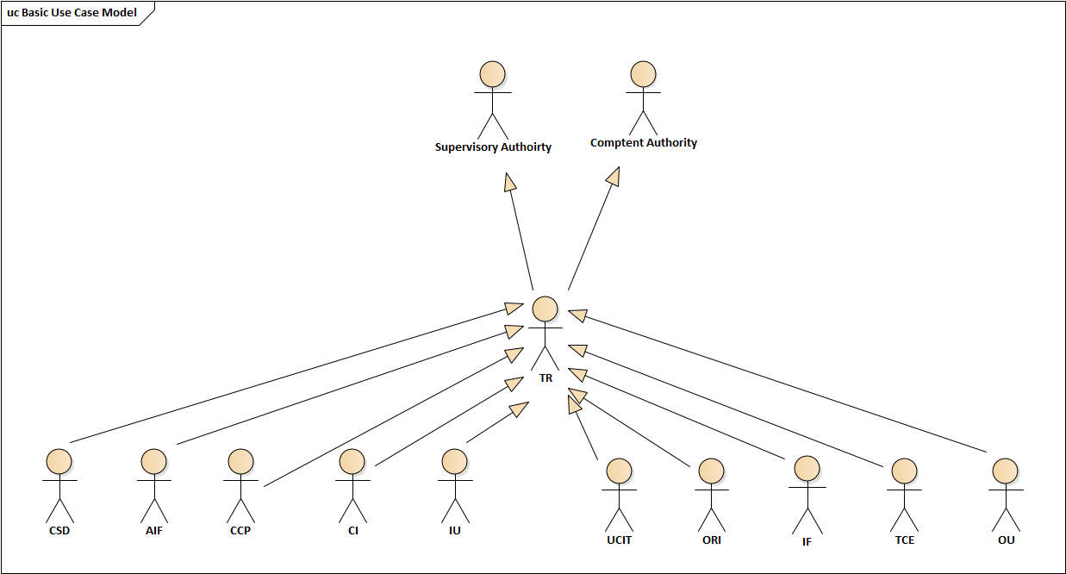

## Participants and BusinessRoles Definition

| **Participants and BusinessRoles definitions** | |
| --- | --- |
| **Description** | **Definition** |
| Participants | |
| Competent Authority | A Competent Authority that will have access to the Access to Trade Repositories System and will use it in order to query and receive TRs’ data. |
| Trade Repository | A Trade Repository that collects data on the SFT and provides it to the Competent Authority |
| Reporting Entity | Any entity that has to report under the scope of SFT Regulation. This data is reported directly to TR |
| Superviosry Authority | Entity which collects, validates and performs all relevant message related operations including tracking on time / late submissions. |
| Business Roles | |
| Investment Firm (IF) | An investment firm authorised in accordance with Directive 2014/65/EU of the European Parliament and of the Counci |
| Credit Institution (CI) | A credit institution authorised in accordance with Directive 2013/36/EU of the European Parliament and of the Council (2) or with Regulation (EU) No 1024/2013; |
| Insurance Undertaking (IU) | An insurance undertaking or a reinsurance undertaking authorised in accordance with Directive 2009/138/EC of the European Parliament and of the Council |
| Undertakings for Collective Investement in Transfarable (UCIT) | A UCITS and, where relevant, its management company, authorised in accordance with Directive 2009/65/EC; |
| Alternative Investment Fund (AIF) | An AIF managed by AIFMs authorised or registered in accordance with Directive 2011/61/EU |
| Occupational Retirement Institution (ORI) | An institution for occupational retirement provision authorised or registered in accordance with Directive 2003/41/EC of the European Parliament and of the Council |
| Central Counterparty (CCP) | A central counterparty authorised in accordance with Regulation (EU) No 648/2012; |
| Central Securites Depository (CSD) | A central securities depository authorised in accordance with Regulation (EU) No 909/2014 of the European Parliament and of the Council (1); |
| Third-country Entity (TCE) | A third-country entity which would require authorisation or registration in accordance with the legislative acts referred to in points (a) to (h) if it were established in the Union; |
| Other Undertakings (OU) | An other undertaking established in the Union or in a third country other than the entities referred to the above points |
| European Securities and Market Authority (ESMA) | European Securities and Markets Authority  A Supervisory Authority performing regulatory tasks.  In some specific cases, ESMA also undertakes regulatory tasks that have been delegated by some National Competent Authorities (such as direct collection of data from reporting entities, as well as transparency calculations). |
| Competent Authority (CA) | National Competent Authority of each EEA member state |
| Trade Repository (TR) | Legal person that centrally collects and maintains the records of SFT |

|  |  |  |  |  |
| --- | --- | --- | --- | --- |
| **BusinessRoles/Participants Matrix Table** | | |  |  |
| Participants  BusinessRoles | Reporting Entity | Trade Repository | Competent Authority | Supervisory Authority |
| IF | x |  |  |  |
| CI | x |  |  |  |
| IU | x |  |  |  |
| UCIT | x |  |  |  |
| AIF | x |  |  |  |
| ORI | x |  |  |  |
| CCP | x |  |  |  |
| CSD | x |  |  |  |
| TCE | x |  |  |  |
| OU | x |  |  |  |
| CA |  |  | x | X |
| ESMA |  |  | x | X |
| TR |  | x |  |  |

# BusinessProcess Description

## BusinessProcess

The below table presents data related processes classified by the entities involved

Table 1 – Type of the report and the entities involved in the data exchange process

|  |  |  |  |
| --- | --- | --- | --- |
| RSE to/from TR | TR to TR | TR to authority | TR to public |
| SFT Report | SFT Report Pairing Request | SFT Report and  SFT Position Data | Weekly aggregates |
| SFT Report Status Advice Feedback | SFT Report Matching Request | SFT Report Rejection Reasons |  |
| SFT Report Reconciliation Status Advice | SFT Report Reconciliation Status Advice | SFT Report Reconciliation Status Advice |  |
| End of Day Report |  | Trade State Report of Outstanding Trades |  |

SFTR defines several information exchange processes which can be classified in the following four groups:

* 1. RSE to/from TR reporting – this process covers the following activities:
     1. generating the relevant SFT reports by the counterparties and subsequent reporting to the TRs;
     2. provision of validation feedback[1] by the TR to the report submitting entity;
     3. provision of reconciliation feedback[2] by the TR to the report submitting entity, reporting counterparties and entities responsible for reporting, as applicable;
     4. at the end of the day, provision, by the TR to RSE, of all of the data submitted to and generated by the TR
  2. TR to TR reporting/data exchange – this process covers the following activities:
     1. pairing and matching of the SFT reports collected by the same TR, i.e. intra-TR reconciliation;
     2. pairing and matching of the SFT reports collected by different TRs, i.e. inter-TR reconciliation;
  3. TR provision to authorities – this process covers:
     1. provision of the reported SFT and calculated position data;
     2. provision of the calculated aggregated position sets data;
     3. provision of the Trade State Report of Outstanding Trades ;
     4. provision of the list of submitted but rejected SFTs, including rejections reasons;
     5. provision of the SFT’ reconciliation results. Additionally to the detailed information on the failed reconciliation status, a weekly delta shall be generated by the TRs and an aggregated information indicating top five fields, per each submitting entity, which failed the reconciliation;
  4. TR data publishing – this process covers:
     1. publication of the weekly SFT aggregates.

Transaction Reporting Messages

Transaction data submission

|  |  |
| --- | --- |
| Item | Description |
| Definition | Any party that has to report transanction data to TR. Reported data is related to the SFTs. |
| Trigger | Data is submitted daily and no later than the close of the following working day transaction was executed. |
| Pre-conditions | Conducted transaction is one of the following type: a repurchase transaction, securities or commodities lending and securities or commodities borrowing, a buy-sell back transaction or sell-buy back transaction, a margin lending transaction |
| Post-conditions | The reporting entity has received a status advice related to the submitted transactions report message. |
| Role | Reporting Entity |

Transaction data reconciliation

|  |  |
| --- | --- |
| Item | Description |
| Definition | TR that has to reconcile transaction reports received from the reporting entities |
| Trigger | TR received transaction report message |
| Pre-conditions | TR received transaction reports from both reporting entities |
| Post-conditions | The reporting entity has received a reconcliation status advice related to the submitted transactions report message. |
| Role | Trade Repository |

Transaction data publication

|  |  |
| --- | --- |
| Item | Description |
| Definition | TR that has to provide transaction report to the CAs and public |
| Trigger | TR received transaction report message |
| Pre-conditions | TR received transaction reports from reporting entities |
| Post-conditions | The reporting entity has received a reconcliation status advice related to the submitted transactions report message. |
| Role | Trade Repository |

# Description of BusinessActivities

This section presents the different BusinessActivities within each BusinessProcess. BusinessActivities of a process are described in swim lane diagrams and are referred in this document as activity diagrams.

The development of an activity diagram is part of the ISO 20022 modelling process and allows capturing the requirements.

The activity diagram provides a zoom-in on the BusinessActivities taking place during each of the BusinessProcesses described in Section 4. It also shows the BusinessActivities that are triggered when another BusinessActivity has a negative result.

What is the activity diagram about?

* It is a diagram representing the ‘common lifecycle’ of a BusinessProcess
* A start point ⚫ shows where the lifecycle of the BusinessProcess commences and the end points show End point where the lifecycle may possibly end
* A lozenge means that a choice between several actions can be made
* A bar means that several actions are initiated in parallel
* The flow of activities between the involved Participants (parties)
* BusinessActivities may result in different actions, that is, information is conveyed from one party to another party.

Both in-scope and out-of-scope activities are included, with a different level of details. There are no information requirements for out-of-scope activities, except that they should be clearly identified in the diagram.

Activity diagrams are always accompanied with a text describing the BusinessActivities and their interactions.

## 5.2. Transaction reporting.

### 5.2.1 SFT reporting overview

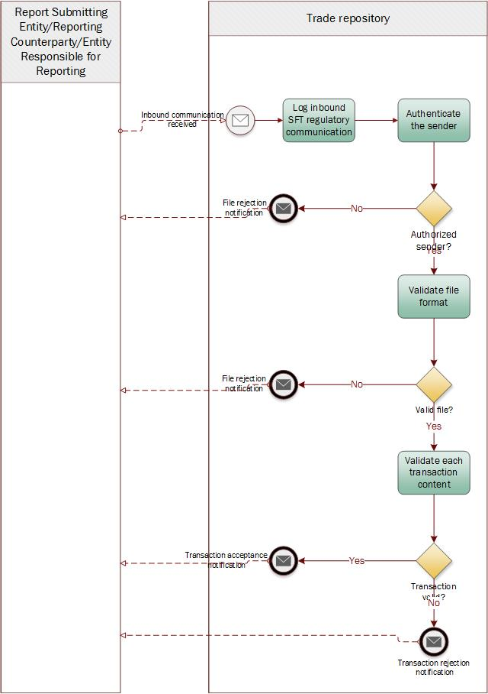

| Step | Description | Initiator |
| --- | --- | --- |
| Log inbound SFT regulatory communication | TR receives data on a security financing transaction from the RSE. | RSE |
| Authenticate the sender | TR authenticates the sender of the SFT related data. If the sender is not authorized, the message will be rejected. | TR |
| Validate file format | TR checks the format of the file received. If the format is not correct, the message will be rejected. | TR |
| Validate each transaction content | TR confirms whether the content of the SFT related report matches the predefined schema. If the content is not correct, the file will be rejected. | TR |

### 5.2.2. SFT reconciliation

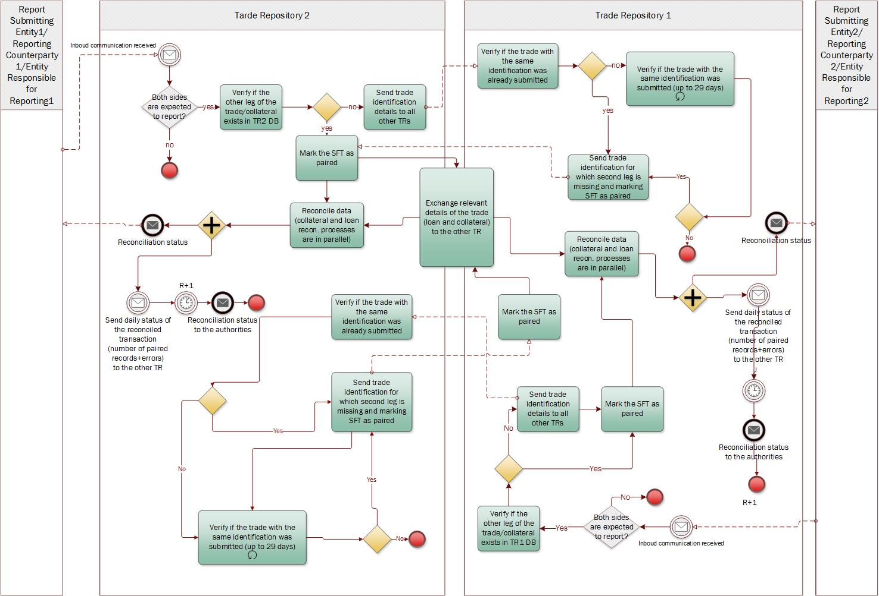

| Step | Description | Initiator |
| --- | --- | --- |
| Inbound communication received | TR2 receives data on a security financing transaction from a reporting entity. | RSE |
| Process Message | TR2 verifies if both parties to the SFT are obliged to report the transaction.  In case only one party is obliged to report, TR2 generates reconciliation status feedback advice noting that the SFT is not subject of reconciliation.  In case both parties are obliged to report TR2 proceeds to the next step | TR2 |
| Verify if the other leg of the trade / collateral exists in TR1 DB | TR2 checks whether information on SFT reported by the second party is already stored in DB of TR2. | TR2 |
| Reconcile data | Data related to the paired transaction are reconciled between two legs of that transaction. The results of the reconciliation process are reported using the reconciliation status feedback advice. | TR2 |
| Reconciliation status submission | The reconciliation status feedback advice is submitted to the entity that submitted the SFT report. | TR2 |
| Send trade identification to all other TRs | In case the SFT data is not paired, TR2 send the details of the unpaired transaction to all other TRs. | TR2 |
| Verifying the existing trade | TR1 verifies whether SFT with the same identifiers already exists in their DB. | TR1 |
| Send trade identification for which second leg is missing and marking SFT as paired | In case the requested SFT exists in the DB of the TR1, confirmation of SFT existence is sent to TR2. | TR2 |
| Exchange relevant details of the trade (loan and collateral) to the other TR | Once the SFT is paired, TR2 shares all the relevant information on the SFT with TR1. | TR1 TR2 |
| Reconcile data (collateral and loan reconciliation processes are in parallel) | TR1, TR2 reconciles the data received with the information currently stored in the DB of TR2. Once this is done, TR1 sends daily status of the reconciled transaction to other TR and the reconciliation status to relevant authorities. | TR1, TR2 |
| Generating status advice | TR1, TR2 generate reconciliation status advice feedback, exchange it between themselves and provide it to the entities that submitted SFT | TR1, TR2 |

### 5.2.3 Reporting of the amendments to the SFT

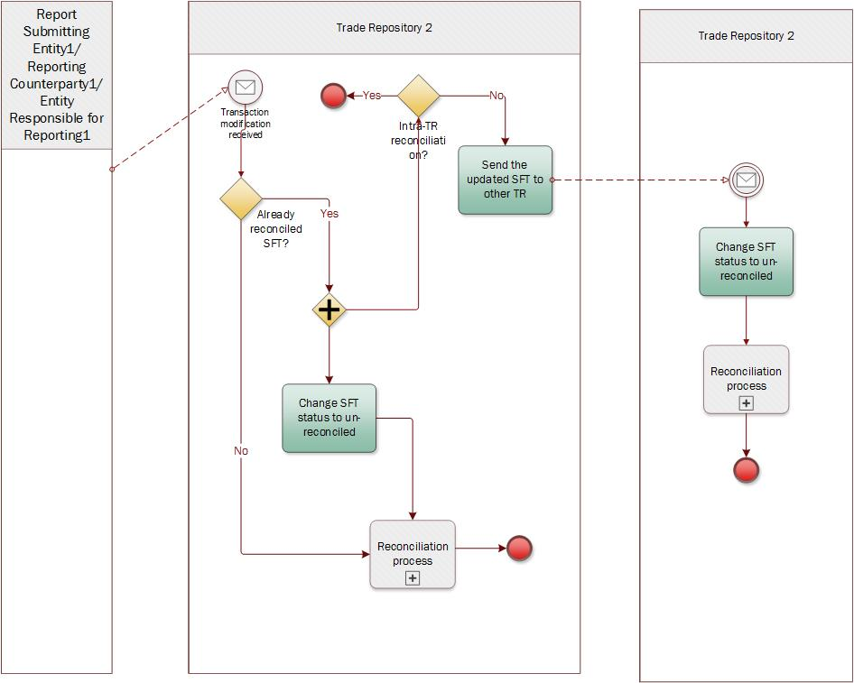

| Step | Description | Initiator |
| --- | --- | --- |
| Inbound communication received | TR2 receives data the SFT from a Report Submitting Entity, Reporting Entity or Entity Responsible for Reporting. | RSE, RE, ERR |
| Message processing | TR2 verifies if submitted transacation has been already reconciled.  In case the SFT had not yet been reconciled, TR2 initiates the reconciliation process.  In case the SFT has been already reconcilied, TR2 changes the status of the SFT to unreconciled and provides the amendment to TR1 (in case SFT was subject of the inter-TR reconciliation). | TR2 |
| Message processing | In case the of the inter-TR reconciled SFT, TR1 changes status of the SFT to ‘Unreconciled’. | TR1 |

### 5.2.4. TR reporting and publication.

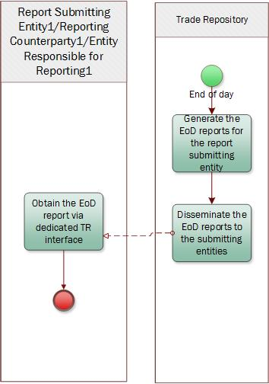

| Step | Description | Initiator |
| --- | --- | --- |
| Generate the EoD reports for the report submitting entity. | TR generates the report based on the data collected during the day. | TR |
| Disseminate the EoD reports to the submitting entities | TR disseminates EoD reports to the RSE. | TR |
| Obtain the EoD report via dedicated TR interface | RSE obtains the EoD with data relevant to the RSE. | RSE |

### 5.2.5 SFT aggregated data publication

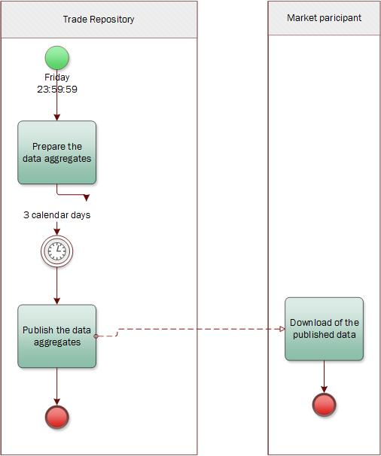

| Step | Description | Initiator |
| --- | --- | --- |
| Prepare the data aggregates. | TR prepares the report of the data aggregates based on the collected. | TR |
| Publish the data aggregates | TR publishes the report containing data aggregates. | TR |
| Download of the published data | MP downloads the data published by the TR. | MP |

### 5.2.6. Data dissemination based on the queries.

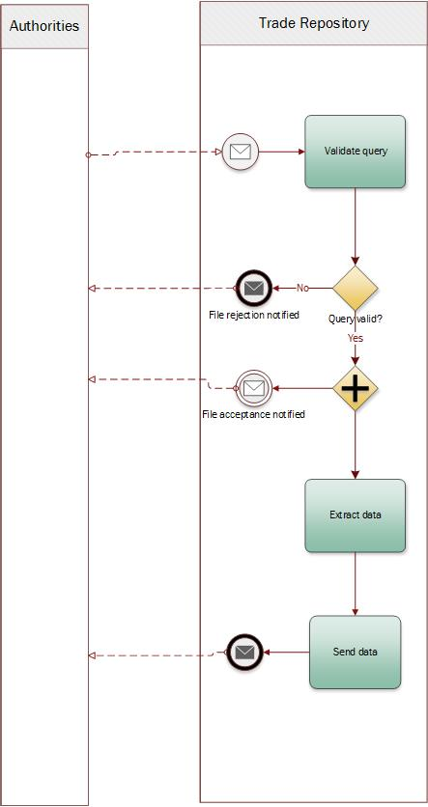

| Step | Description | Initiator |
| --- | --- | --- |
| Validate query | TR validates the query received. Based on the validation, rejection or acceptance message is sent back to Authority. | CA |
| Extract data | In case the file is accepted, TR extracts the data and sends it to the Authority. | TR |

### 5.2.7. SFT position data aggregation

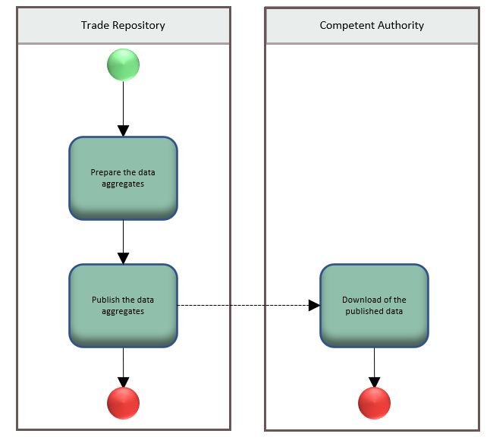

| Step | Description | Initiator |
| --- | --- | --- |
| Prepare the data aggregates. | TR prepares the report with the calculated aggregated position sets. | TR |
| Publish the data aggregates | TR publishes the report containing data aggregates. | TR |
| Download of the published data | CA downloads the data published by the TR. | CA |

# BusinessTransactions

This section describes the message flows based on the activity diagrams documented above. It shows the typical exchanges of information in the context of a BusinessTransaction.

## SFT Reporting

This flow describes RE/RSE/RRE submitting Transaction Reporting Messages to TR. TR is responsible for all data checking operations on the received message and directly replies to the entity that submitted the SFT. It also exchanges relevant data with other relevant TR and CA.

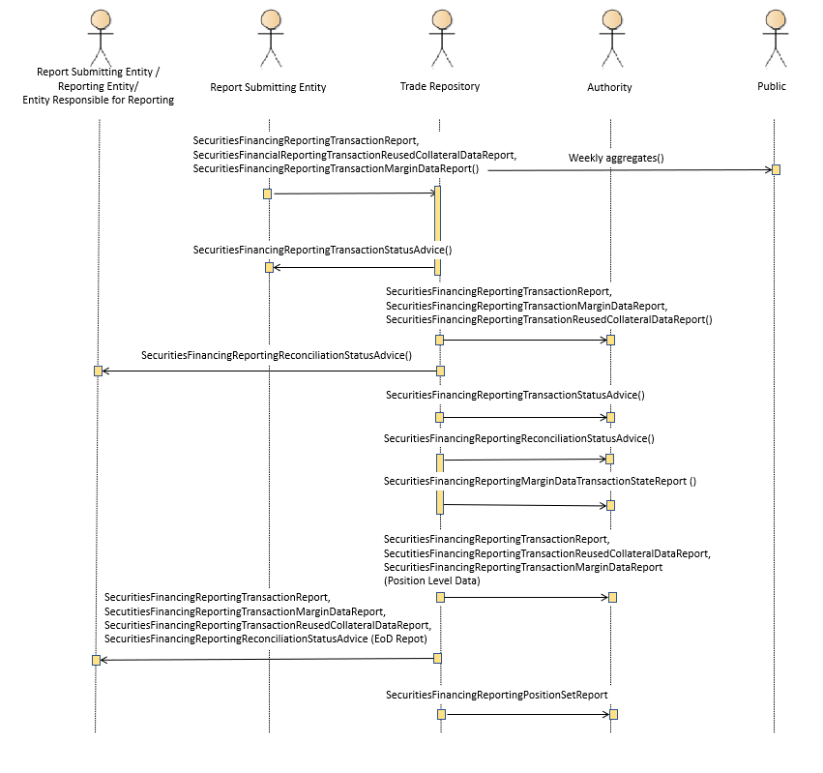

## SFT Reconciliation

This flow describes the reconciliation of the submitted SFTs by two different TRs (so called inter-TR reconciliation process).

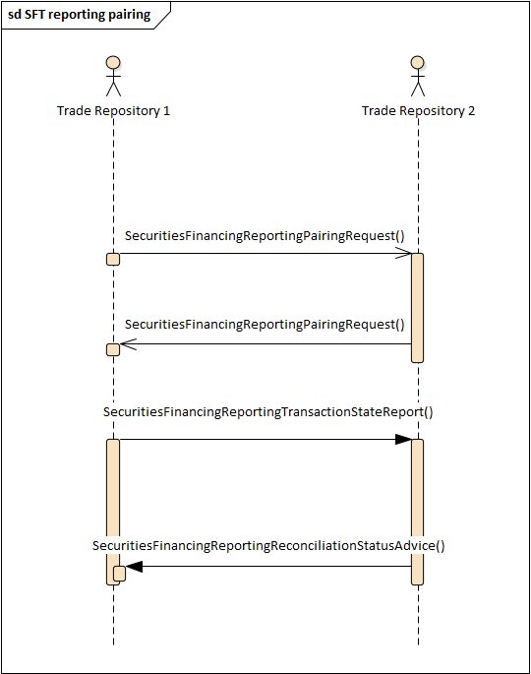

# Examples

This section describes business examples of the use of the various MessageDefinitions. Each example starts with a description of the example scenario followed by the actual MessageInstance.

## SFT Status Advice

### auth.031.001.01

**Description**

The following MessageInstance 1 provides an example of a status advice message from a Trade Repository, which confirms the validation of a received query message.

**MessageInstance 1:**

<?xml version="1.0" encoding="UTF-8"?>

<Document xmlns:xsi="http://www.w3.org/2001/XMLSchema-instance" xmlns="urn:iso:std:iso:20022:tech:xsd:auth.031.001.01">

<FinInstrmRptgStsAdvc>

<StsAdvc>

<MsgSts>

<Sts>ACPT</Sts>

</MsgSts>

</StsAdvc>

</FinInstrmRptgStsAdvc>

The following MessageInstance 2 provides an example of a status advice message from a System to Trade Repository with a reminder that the response to query is missing.

**MessageInstance 2:**

<?xml version="1.0" encoding="UTF-8"?>

<Document xmlns:xsi="http://www.w3.org/2001/XMLSchema-instance" xmlns="urn:iso:std:iso:20022:tech:xsd:auth.031.001.01">

<FinInstrmRptgStsAdvc>

<StsAdvc>

<MsgSts>

<Sts>RMDR</Sts>

<VldtnRule>

<Id>FIL-020</Id>

<Desc>Response to query is missing.</Desc>

</VldtnRule>

<MsgDt>2020-10-21Z</MsgDt>

</MsgSts>

</StsAdvc>

</FinInstrmRptgStsAdvc>

## SFT Report

### auth.052.001.02

**Description**

The SecuritiesFinancingReportingTransactionReport message is submiited by the entity with LEI 52990017GLIR85C42436 to the trade repository (TR) to report on the securities financing transactions.

**Message Instance**

<?xml version="1.0" encoding="UTF-8"?>

<Document xmlns:xsi="http://www.w3.org/2001/XMLSchema-instance" xmlns="urn:iso:std:iso:20022:tech:xsd:auth.052.001.02">

<SctiesFincgRptgTxRpt>

<Rpt>

<New>

<TechRcrdId>a</TechRcrdId>

<CtrPtySpcfcData>

<RptgDtTm>2021-12-17T09:30:47Z</RptgDtTm>

<RptSubmitgNtty>

<LEI>52990017GLIR85C42436</LEI>

</RptSubmitgNtty>

<CtrPty>

<RptgCtrPty>

<Id>

<LEI>52990017GLIR85C42436</LEI>

</Id>

<Ntr>

<FI>

<Clssfctn>CDTI</Clssfctn>

</FI>

</Ntr>

<Brnch>

<Ctry>PL</Ctry>

</Brnch>

<Sd>TAKE</Sd>

</RptgCtrPty>

<OthrCtrPty>

<Id>

<Lgl>

<LEI>52990017GLIR85C42436</LEI>

</Lgl>

</Id>

<Brnch>

<Ctry>PL</Ctry>

</Brnch>

<CtryCd>PL</CtryCd>

</OthrCtrPty>

<NttyRspnsblForRpt>

<LEI>52990017GLIR85C42436</LEI>

</NttyRspnsblForRpt>

<OthrPtyData>

<Bnfcry>

<Lgl>

<LEI>52990017GLIR85C42436</LEI>

</Lgl>

</Bnfcry>

<TrptyAgt>

<LEI>52990017GLIR85C42436</LEI>

</TrptyAgt>

<Brkr>

<LEI>52990017GLIR85C42436</LEI>

</Brkr>

<ClrMmb>

<LEI>52990017GLIR85C42436</LEI>

</ClrMmb>

<SttlmPties>

<CntrlSctiesDpstryPtcpt>

<LEI>52990017GLIR85C42436</LEI>

</CntrlSctiesDpstryPtcpt>

</SttlmPties>

<AgtLndr>

<LEI>52990017GLIR85C42436</LEI>

</AgtLndr>

</OthrPtyData>

</CtrPty>

</CtrPtySpcfcData>

<LnData>

<RpTrad>

<UnqTradIdr>E01KDPW000NT2014110303423SELL008</UnqTradIdr>

<EvtDt>2021-08-13</EvtDt>

<ExctnDtTm>2021-12-17T09:30:47Z</ExctnDtTm>

<ClrSts>

<Clrd>

<CCP>

<LEI>52990017GLIR85C42436</LEI>

</CCP>

<ClrDtTm>2021-12-17T09:30:47Z</ClrDtTm>

<RptTrckgNb>E01KDPW000NT2014110303423SELL008</RptTrckgNb>

<PrtflCd>DHYYA83.JFSI7_KSJFUXZ2_JSOF.JFISO</PrtflCd>

</Clrd>

</ClrSts>

<TradgVn>XWAR</TradgVn>

<MstrAgrmt>

<Tp>

<Tp>CHRA</Tp>

</Tp>

<Vrsn>1900</Vrsn>

<OthrMstrAgrmtDtls>OtherMasterAgreementType0000</OthrMstrAgrmtDtls>

</MstrAgrmt>

<ValDt>2021-08-13</ValDt>

<MinNtcePrd>30</MinNtcePrd>

<EarlstCallBckDt>2021-08-13</EarlstCallBckDt>

<GnlColl>GENE</GnlColl>

<DlvryByVal>true</DlvryByVal>

<CollDlvryMtd>TTCA</CollDlvryMtd>

<Term>

<Opn>

<MtrtyDt>2021-08-13</MtrtyDt>

<TermntnOptn>EGRN</TermntnOptn>

</Opn>

</Term>

<IntrstRate>

<Fxd>

<Rate>43.7634</Rate>

<DayCntBsis>

<Cd>A002</Cd>

</DayCntBsis>

</Fxd>

</IntrstRate>

<PrncplAmt>

<ValDtAmt Ccy="EUR">100</ValDtAmt>

<MtrtyDtAmt Ccy="EUR">100</MtrtyDtAmt>

</PrncplAmt>

</RpTrad>

</LnData>

<CollData>

<RpTrad>

<AsstTp>

<Scty>

<Id>XS1998999616</Id>

<ClssfctnTp>OCABPS</ClssfctnTp>

<QtyOrNmnlVal>

<Qty>10</Qty>

</QtyOrNmnlVal>

<UnitPric>

<MntryVal>

<Amt Ccy="EUR">100</Amt>

</MntryVal>

</UnitPric>

<MktVal>

<Amt Ccy="EUR">100</Amt>

</MktVal>

<Qlty>NIVG</Qlty>

<Mtrty>2021-08-13</Mtrty>

<Issr>

<JursdctnCtry>PL</JursdctnCtry>

</Issr>

<Tp>

<Cd>OTHR</Cd>

</Tp>

<HrcutOrMrgn>77.93874</HrcutOrMrgn>

</Scty>

<Csh>

<Amt>

<Amt Ccy="EUR">100</Amt>

</Amt>

<HrcutOrMrgn>77.93874</HrcutOrMrgn>

</Csh>

<Cmmdty>

<Clssfctn>

<Agrcltrl>

<GrnOilSeed>

<BasePdct>AGRI</BasePdct>

<SubPdct>GROS</SubPdct>

<AddtlSubPdct>CORN</AddtlSubPdct>

</GrnOilSeed>

</Agrcltrl>

</Clssfctn>

<Qty>

<Val>0</Val>

<UnitOfMeasr>SQMI</UnitOfMeasr>

</Qty>

<UnitPric>

<MntryVal>

<Amt Ccy="EUR">100</Amt>

</MntryVal>

</UnitPric>

<MktVal>

<Amt Ccy="EUR">100</Amt>

</MktVal>

</Cmmdty>

</AsstTp>

<NetXpsrCollstnInd>true</NetXpsrCollstnInd>

<BsktIdr>

<Id>XS1998999616</Id>

</BsktIdr>

<AvlblForCollReuse>true</AvlblForCollReuse>

</RpTrad>

</CollData>

<LvlTp>TCTN</LvlTp>

</New>

</Rpt>

</SctiesFincgRptgTxRpt>

</Document>

## SFT Report Margin Data

### auth.070.001.02

**Description**

The SecuritiesFinancingReportingTransactionReportMarginData message is sent by the reporting agent to the trade repository (TR) to report the margin applied on the securities financing transactions.

**Message Instance**

<?xml version="1.0" encoding="UTF-8"?>

<Document xmlns:xsi="http://www.w3.org/2001/XMLSchema-instance" xmlns="urn:iso:std:iso:20022:tech:xsd:auth.070.001.02">

<SctiesFincgRptgTxMrgnDataRpt>

<Rpt>

<New>

<TechRcrdId>a</TechRcrdId>

<RptgDtTm>2021-12-17T09:30:47Z</RptgDtTm>

<EvtDt>2021-08-13</EvtDt>

<CtrPty>

<RptgCtrPty>

<LEI>52990017GLIR85C42436</LEI>

</RptgCtrPty>

<OthrCtrPty>

<Lgl>

<LEI>52990017GLIR85C42436</LEI>

</Lgl>

</OthrCtrPty>

<NttyRspnsblForRpt>

<LEI>52990017GLIR85C42436</LEI>

</NttyRspnsblForRpt>

<RptSubmitgNtty>

<LEI>52990017GLIR85C42436</LEI>

</RptSubmitgNtty>

</CtrPty>

<CollPrtflId>1000</CollPrtflId>

<PstdMrgnOrColl>

<InitlMrgnPstd Ccy="EUR">100</InitlMrgnPstd>

<VartnMrgnPstd Ccy="EUR">100</VartnMrgnPstd>

<XcssCollPstd Ccy="EUR">100</XcssCollPstd>

</PstdMrgnOrColl>

<RcvdMrgnOrColl>

<InitlMrgnRcvd Ccy="EUR">100</InitlMrgnRcvd>

<VartnMrgnRcvd Ccy="EUR">100</VartnMrgnRcvd>

<XcssCollRcvd Ccy="EUR">100</XcssCollRcvd>

</RcvdMrgnOrColl>

</New>

</Rpt>

</SctiesFincgRptgTxMrgnDataRpt>

</Document>

## SFT Report Margin State Data

### auth.085.001.02

**Description**

The SecuritiesFinancingReportingMarginDataTransactionStateReport message is sent by the reporting agent to the trade repository (TR) to report the margin applied on the securities financing state.

**Message Instance**

<?xml version="1.0" encoding="UTF-8"?>

<Document xmlns:xsi="http://www.w3.org/2001/XMLSchema-instance" xmlns="urn:iso:std:iso:20022:tech:xsd:auth.085.001.02">

<SctiesFincgRptgMrgnDataTxStatRpt>

<Stat>

<TechRcrdId>a</TechRcrdId>

<RptgDtTm>2021-12-17T09:30:47Z</RptgDtTm>

<EvtDt>2021-08-13</EvtDt>

<CtrPty>

<RptgCtrPty>

<LEI>52990017GLIR85C42436</LEI>

</RptgCtrPty>

<OthrCtrPty>

<Lgl>

<LEI>52990017GLIR85C42436</LEI>

</Lgl>

</OthrCtrPty>

<NttyRspnsblForRpt>

<LEI>52990017GLIR85C42436</LEI>

</NttyRspnsblForRpt>

<RptSubmitgNtty>

<LEI>52990017GLIR85C42436</LEI>

</RptSubmitgNtty>

</CtrPty>

<CollPrtflId>DHYYA83.JFSI7_KSJFUXZ2_JSOF.JFISO</CollPrtflId>

<PstdMrgnOrColl>

<InitlMrgnPstd Ccy="EUR">100</InitlMrgnPstd>

<VartnMrgnPstd Ccy="EUR">100</VartnMrgnPstd>

<XcssCollPstd Ccy="EUR">100</XcssCollPstd>

</PstdMrgnOrColl>

<RcvdMrgnOrColl>

<InitlMrgnRcvd Ccy="EUR">100</InitlMrgnRcvd>

<VartnMrgnRcvd Ccy="EUR">100</VartnMrgnRcvd>

<XcssCollRcvd Ccy="EUR">100</XcssCollRcvd>

</RcvdMrgnOrColl>

<CtrctMod>

<ActnTp>MARU</ActnTp>

<Lvl>TCTN</Lvl>

</CtrctMod>

</Stat>

</SctiesFincgRptgMrgnDataTxStatRpt>

</Document>

## SFT Report Reuse Data

### auth.071.001.02

**Description**

The SecuritiesFinancingReportingTransactionReportReuseData message is sent by the reporting agent identified by the LEI 52990017GLIR85C42436 to the trade repository (TR) to report the collateral reused.

**Message Instance**

<?xml version="1.0" encoding="UTF-8"?>

<Document xmlns:xsi="http://www.w3.org/2001/XMLSchema-instance" xmlns="urn:iso:std:iso:20022:tech:xsd:auth.071.001.02">

<SctiesFincgRptgTxReusdCollDataRpt>

<Rpt>

<New>

<TechRcrdId>a</TechRcrdId>

<RptgDtTm>2021-12-17T09:30:47Z</RptgDtTm>

<CtrPty>

<RptSubmitgNtty>

<LEI>52990017GLIR85C42436</LEI>

</RptSubmitgNtty>

<RptgCtrPty>

<LEI>52990017GLIR85C42436</LEI>

</RptgCtrPty>

<NttyRspnsblForRpt>

<LEI>52990017GLIR85C42436</LEI>

</NttyRspnsblForRpt>

</CtrPty>

<CollCmpnt>

<Scty>

<ISIN>XS1998999616</ISIN>

<ReuseVal>

<Actl Ccy="EUR">100</Actl>

</ReuseVal>

</Scty>

<Csh>

<RinvstdCsh>

<Tp>SDPU</Tp>

<RinvstdCshAmt Ccy="EUR">100</RinvstdCshAmt>

</RinvstdCsh>

<CshRinvstmtRate>5736.2877</CshRinvstmtRate>

</Csh>

</CollCmpnt>

<EvtDay>2021-08-13</EvtDay>

<FndgSrc>

<Tp>CSHS</Tp>

<MktVal>

<Amt Ccy="EUR">100</Amt>

<Sgn>true</Sgn>

</MktVal>

</FndgSrc>

</New>

</Rpt>

</SctiesFincgRptgTxReusdCollDataRpt>

</Document>

## SFT State Report Reuse Data

### auth.086.001.02

**Description**

The SecuritiesFinancingReportingReusedColllateralDataTransactionStateReport message is sent by the reporting agent identified by the LEI 52990017GLIR85C42436 to the trade repository (TR) to report the state of the collateral reused.

**Message Instance**

<?xml version="1.0" encoding="UTF-8"?>

<Document xmlns:xsi="http://www.w3.org/2001/XMLSchema-instance" xmlns="urn:iso:std:iso:20022:tech:xsd:auth.086.001.02">

<SctiesFincgRptgReusdCollDataTxStatRpt>

<Stat>

<TechRcrdId>a</TechRcrdId>

<CtrPty>

<RptSubmitgNtty>

<LEI>52990017GLIR85C42436</LEI>

</RptSubmitgNtty>

<RptgCtrPty>

<LEI>52990017GLIR85C42436</LEI>

</RptgCtrPty>

<NttyRspnsblForRpt>

<LEI>52990017GLIR85C42436</LEI>

</NttyRspnsblForRpt>

</CtrPty>

<CollCmpnt>

<Scty>

<ISIN>XS1998999616</ISIN>

<ReuseVal>

<Actl Ccy="EUR">100</Actl>

</ReuseVal>

</Scty>

<Csh>

<RinvstdCsh>

<Tp>OTHR</Tp>

<RinvstdCshAmt Ccy="EUR">100</RinvstdCshAmt>

</RinvstdCsh>

<CshRinvstmtRate>5736.2877</CshRinvstmtRate>

</Csh>

</CollCmpnt>

<EvtDay>2021-08-13</EvtDay>

<RptgDtTm>2021-12-17T09:30:47Z</RptgDtTm>

<FndgSrc>

<Tp>SECL</Tp>

<MktVal>

<Amt Ccy="EUR">100</Amt>

<Sgn>true</Sgn>

</MktVal>

</FndgSrc>

<CtrctMod>

<ActnTp>CORR</ActnTp>

<Lvl>PSTN</Lvl>

</CtrctMod>

</Stat>

</SctiesFincgRptgReusdCollDataTxStatRpt>

</Document>

## SFT Report Pairing Request

### auth.078.001.02

**Description**

The SecuritiesFinancingReportingPairingRequest is sent by the trade repository (TR) to the other trade repositories (TRs) in order to identify the trade repository (TR) holding information on a second leg of a given transaction.

**Message Instance**

<?xml version="1.0" encoding="UTF-8"?>

<Document xmlns:xsi="http://www.w3.org/2001/XMLSchema-instance" xmlns="urn:iso:std:iso:20022:tech:xsd:auth.078.001.02">

<SctiesFincgRptgPairgReq>

<TxId>

<RptgCtrPty>

<LEI>52990017GLIR85C42436</LEI>

</RptgCtrPty>

<OthrCtrPty>

<LEI>52990017GLIR85C42436</LEI>

</OthrCtrPty>

<UnqTradIdr>E01KDPW000NT2014110303423SELL008</UnqTradIdr>

<MstrAgrmt>

<Tp>

<Tp>CHRA</Tp>

</Tp>

<Vrsn>1900</Vrsn>

<OthrMstrAgrmtDtls>OtherMasterAgreementType0000</OthrMstrAgrmtDtls>

</MstrAgrmt>

<AgtLndr>

<LEI>52990017GLIR85C42436</LEI>

</AgtLndr>

<TrptyAgt>

<LEI>52990017GLIR85C42436</LEI>

</TrptyAgt>

</TxId>

</SctiesFincgRptgPairgReq>

</Document>

## SFT Matching Request

### auth.079.001.02

**Description**

The SecuritiesFinancingReportingMatchingRequest is sent by the trade repository (TR) to the other trade repository (TR) containing information being a subject of a reconciliation

**Message Instance**

<?xml version="1.0" encoding="UTF-8"?>

<Document xmlns:xsi="http://www.w3.org/2001/XMLSchema-instance" xmlns="urn:iso:std:iso:20022:tech:xsd:auth.079.001.02">

<SctiesFincgRptgTxStatRpt>

<Stat>

<TechRcrdId>a</TechRcrdId>

<CtrPtySpcfcData>

<RptgDtTm>2021-12-17T09:30:47Z</RptgDtTm>

<RptSubmitgNtty>

<LEI>52990017GLIR85C42436</LEI>

</RptSubmitgNtty>

<CtrPty>

<RptgCtrPty>

<Id>

<LEI>52990017GLIR85C42436</LEI>

</Id>

<Ntr>

<FI>

<Clssfctn>CDTI</Clssfctn>

</FI>

</Ntr>

<Brnch>

<Ctry>PL</Ctry>

</Brnch>

<Sd>TAKE</Sd>

</RptgCtrPty>

<OthrCtrPty>

<Id>

<Lgl>

<LEI>52990017GLIR85C42436</LEI>

</Lgl>

</Id>

<Brnch>

<Ctry>PL</Ctry>

</Brnch>

<CtryCd>PL</CtryCd>

</OthrCtrPty>

<NttyRspnsblForRpt>

<LEI>52990017GLIR85C42436</LEI>

</NttyRspnsblForRpt>

<OthrPtyData>

<Bnfcry>

<Lgl>

<LEI>52990017GLIR85C42436</LEI>

</Lgl>

</Bnfcry>

<TrptyAgt>

<LEI>52990017GLIR85C42436</LEI>

</TrptyAgt>

<Brkr>

<LEI>52990017GLIR85C42436</LEI>

</Brkr>

<ClrMmb>

<LEI>52990017GLIR85C42436</LEI>

</ClrMmb>

<SttlmPties>

<CntrlSctiesDpstryPtcpt>

<LEI>52990017GLIR85C42436</LEI>

</CntrlSctiesDpstryPtcpt>

</SttlmPties>

<AgtLndr>

<LEI>52990017GLIR85C42436</LEI>

</AgtLndr>

</OthrPtyData>

</CtrPty>

</CtrPtySpcfcData>

<LnData>

<RpTrad>

<UnqTradIdr>E01KDPW000NT2014110303423SELL008</UnqTradIdr>

<EvtDt>2021-08-13</EvtDt>

<ExctnDtTm>2021-12-17T09:30:47Z</ExctnDtTm>

<ClrSts>

<Clrd>

<CCP>

<LEI>52990017GLIR85C42436</LEI>

</CCP>

<ClrDtTm>2021-12-17T09:30:47Z</ClrDtTm>

<RptTrckgNb>E01KDPW000NT2014110303423SELL008</RptTrckgNb>

<PrtflCd>DHYYA83.JFSI7_KSJFUXZ2_JSOF.JFISO</PrtflCd>

</Clrd>

</ClrSts>

<TradgVn>XWAR</TradgVn>

<MstrAgrmt>

<Tp>

<Tp>JPBL</Tp>

</Tp>

<Vrsn>1900</Vrsn>

<OthrMstrAgrmtDtls>OtherMasterAgreementType0000</OthrMstrAgrmtDtls>

</MstrAgrmt>

<ValDt>2021-08-13</ValDt>

<MinNtcePrd>30</MinNtcePrd>

<EarlstCallBckDt>2021-08-13</EarlstCallBckDt>

<GnlColl>GENE</GnlColl>

<DlvryByVal>true</DlvryByVal>

<CollDlvryMtd>SIUR</CollDlvryMtd>

<Term>

<Opn>

<MtrtyDt>2021-08-13</MtrtyDt>

<TermntnOptn>NOAP</TermntnOptn>

</Opn>

</Term>

<IntrstRate>

<Fxd>

<Rate>43.7634</Rate>

<DayCntBsis>

<Cd>A013</Cd>

</DayCntBsis>

</Fxd>

</IntrstRate>

<PrncplAmt>

<ValDtAmt Ccy="EUR">100</ValDtAmt>

<MtrtyDtAmt Ccy="EUR">100</MtrtyDtAmt>

</PrncplAmt>

<TermntnDt>2021-08-13</TermntnDt>

</RpTrad>

</LnData>

<CollData>

<RpTrad>

<CollValDt>2021-08-13</CollValDt>

<AsstTp>

<Scty>

<Id>XS1998999616</Id>

<ClssfctnTp>OCABPS</ClssfctnTp>

<QtyOrNmnlVal>

<Qty>10</Qty>

</QtyOrNmnlVal>

<UnitPric>

<MntryVal>

<Amt Ccy="EUR">100</Amt>

</MntryVal>

</UnitPric>

<MktVal>

<Amt Ccy="EUR">100</Amt>

<Sgn>true</Sgn>

</MktVal>

<Qlty>NOTR</Qlty>

<Mtrty>2021-08-13</Mtrty>

<Issr>

<Id>

<LEI>52990017GLIR85C42436</LEI>

</Id>

<JursdctnCtry>PL</JursdctnCtry>

</Issr>

<Tp>

<Cd>MEQU</Cd>

</Tp>

<HrcutOrMrgn>77.93874</HrcutOrMrgn>

</Scty>

<Csh>

<Amt>

<Amt Ccy="EUR">100</Amt>

<Sgn>true</Sgn>

</Amt>

<HrcutOrMrgn>77.93874</HrcutOrMrgn>

</Csh>

<Cmmdty>

<Clssfctn>

<Agrcltrl>

<GrnOilSeed>

<BasePdct>AGRI</BasePdct>

<SubPdct>GROS</SubPdct>

<AddtlSubPdct>OTHR</AddtlSubPdct>

</GrnOilSeed>

</Agrcltrl>

</Clssfctn>

<Qty>

<Val>10</Val>

<UnitOfMeasr>CELI</UnitOfMeasr>

</Qty>

<UnitPric>

<MntryVal>

<Amt Ccy="EUR">100</Amt>

</MntryVal>

</UnitPric>

<MktVal>

<Amt Ccy="EUR">100</Amt>

<Sgn>true</Sgn>

</MktVal>

</Cmmdty>

</AsstTp>

<NetXpsrCollstnInd>true</NetXpsrCollstnInd>

<BsktIdr>

<Id>XS1998999616</Id>

</BsktIdr>

<AvlblForCollReuse>true</AvlblForCollReuse>

</RpTrad>

</CollData>

<RcncltnFlg>

<RptTp>TWOS</RptTp>

<BothCtrPtiesRptg>true</BothCtrPtiesRptg>

<PairdSts>true</PairdSts>

<LnRcncltnSts>true</LnRcncltnSts>

<CollRcncltnSts>true</CollRcncltnSts>

<ModSts>true</ModSts>

</RcncltnFlg>

<CtrctMod>

<ActnTp>NEWT</ActnTp>

<Lvl>TCTN</Lvl>

</CtrctMod>

</Stat>

</SctiesFincgRptgTxStatRpt>

</Document>

## SFT Report Reconciliation Status Advice

### auth.080.001.02

**Description**

The SecuritesFinancingReportingReconciliationStatusAdvice message is sent by the trade repositories (TRs) to the reporting agent to provide a status advice for the correctness, issues or errors that arise.

**Message Instance**

<?xml version="1.0" encoding="UTF-8"?>

<Document xmlns:xsi="http://www.w3.org/2001/XMLSchema-instance" xmlns="urn:iso:std:iso:20022:tech:xsd:auth.080.001.02">

<SctiesFincgRptgRcncltnStsAdvc>

<RcncltnData>

<Rpt>

<PairgRcncltnSts>

<DtldNbOfRpts>100</DtldNbOfRpts>

<DtldSts>CLRC</DtldSts>

</PairgRcncltnSts>

<RcncltnRpt>

<TechRcrdId>a</TechRcrdId>

<TxId>

<RptgCtrPty>

<LEI>52990017GLIR85C42436</LEI>

</RptgCtrPty>

<OthrCtrPty>

<Lgl>

<LEI>52990017GLIR85C42436</LEI>

</Lgl>

</OthrCtrPty>

<NttyRspnsblForRpt>

<LEI>52990017GLIR85C42436</LEI>

</NttyRspnsblForRpt>

<UnqTradIdr>E01KDPW000NT2014110303423SELL008</UnqTradIdr>

<MstrAgrmt>

<Tp>

<Tp>MRAA</Tp>

</Tp>

<Vrsn>1900</Vrsn>

<OthrMstrAgrmtDtls>OtherMasterAgreementType0000</OthrMstrAgrmtDtls>

</MstrAgrmt>

<AgtLndr>

<LEI>52990017GLIR85C42436</LEI>

</AgtLndr>

<TrptyAgt>

<LEI>52990017GLIR85C42436</LEI>

</TrptyAgt>

</TxId>

<Modfd>true</Modfd>

<RcncltnSts>

<NoRcncltnReqrd>NORE</NoRcncltnReqrd>

</RcncltnSts>

</RcncltnRpt>

</Rpt>

</RcncltnData>

</SctiesFincgRptgRcncltnStsAdvc>

</Document>

## SFT Missing Collaterals

### auth.083.001.02

**Description**

The SecuritiesFinancingReportingMissingCollatera is sent by the trade repositories (TRs) to the reporting entities (REs) with a request to submit collateral information for a given trade.

**Message Instance**

<?xml version="1.0" encoding="UTF-8"?>

<Document xmlns:xsi="http://www.w3.org/2001/XMLSchema-instance" xmlns="urn:iso:std:iso:20022:tech:xsd:auth.083.001.02">

<SctiesFincgRptgMssngCollReq>

<TxId>

<RptgCtrPty>

<LEI>52990017GLIR85C42436</LEI>

</RptgCtrPty>

<OthrCtrPty>

<Lgl>

<LEI>52990017GLIR85C42436</LEI>

</Lgl>

</OthrCtrPty>

<UnqTradIdr>E01KDPW000NT2014110303423SELL008</UnqTradIdr>

<MstrAgrmt>

<Tp>

<Tp>MRAA</Tp>

</Tp>

<Vrsn>1900</Vrsn>

<OthrMstrAgrmtDtls>OtherMasterAgreementType0000</OthrMstrAgrmtDtls>

</MstrAgrmt>

</TxId>

</SctiesFincgRptgMssngCollReq>

</Document>

## SFT Rejection Reason Report

### auth.084.001.02

**Description**

The SecuritiesFinancingReportingTransactionReportRejectionReasons message is sent by the trade repository (TR) to the competent authority (CA) identifying the transactions rejected and the reasons for a rejection.

**Message Instance**

<?xml version="1.0" encoding="UTF-8"?>

<Document xmlns:xsi="http://www.w3.org/2001/XMLSchema-instance" xmlns="urn:iso:std:iso:20022:tech:xsd:auth.084.001.02">

<SctiesFincgRptgTxStsAdvc>

<TxRptStsAndRsn>

<Rpt>

<RptSttstcs>

<TtlNbOfRpts>2</TtlNbOfRpts>

<TtlNbOfRptsAccptd>1</TtlNbOfRptsAccptd>

<TtlNbOfRptsRjctd>2</TtlNbOfRptsRjctd>

<NbOfRptsRjctdPerErr>

<DtldNb>1</DtldNb>

<RptSts>

<MsgRptId>1</MsgRptId>

<Sts>ACPT</Sts>

<DtldVldtnRule>

<Id>ERR01</Id>

<Desc>ISIN is not valid</Desc>

<SchmeNm>

<Cd>1</Cd>

</SchmeNm>

<Issr>IssuerA</Issr>

</DtldVldtnRule>

</RptSts>

</NbOfRptsRjctdPerErr>

</RptSttstcs>

<TxSttstcs>

<DataSetActn>NOTX</DataSetActn>

</TxSttstcs>

</Rpt>

</TxRptStsAndRsn>

</SctiesFincgRptgTxStsAdvc>

</Document>

## SFT Transaction Query Report

### auth.094.001.02

**Description**

The SecuritiesFinancingReportingTransactionQuery message is sent by the CA to the the trade repository (TR) and defines query criteria.

**Message Instance**

<?xml version="1.0" encoding="UTF-8"?>

<Document xmlns:xsi="http://www.w3.org/2001/XMLSchema-instance" xmlns="urn:iso:std:iso:20022:tech:xsd:auth.094.001.02">

<SctiesFincgRptgTxQry>

<RqstngAuthrty>

<AnyBIC>BPKOPLPW</AnyBIC>

</RqstngAuthrty>

<TradQryData>

<AdHocQry>

<TradLifeCyclHstry>true</TradLifeCyclHstry>

<OutsdngTradInd>true</OutsdngTradInd>

<TradPtyCrit>

<Oprtr>ANDD</Oprtr>

<RptgCtrPty>

<LEI>52990017GLIR85C42436</LEI>

<AnyBIC>BPKOPLPW</AnyBIC>

<ClntId>BKPKO</ClntId>

<NotRptd>NORP</NotRptd>

</RptgCtrPty>

<RptgCtrPtyBrnch>

<CtryCd>PL</CtryCd>

<NotRptd>NORP</NotRptd>

</RptgCtrPtyBrnch>

<OthrCtrPty>

<LEI>52990017GLIR85C42436</LEI>

<AnyBIC>BPKOPLPW</AnyBIC>

<ClntId>BKPKO</ClntId>

<NotRptd>NORP</NotRptd>

</OthrCtrPty>

<OthrCtrPtyBrnch>

<CtryCd>PL</CtryCd>

<NotRptd>NORP</NotRptd>

</OthrCtrPtyBrnch>

<Bnfcry>

<LEI>52990017GLIR85C42436</LEI>

<AnyBIC>BPKOPLPW</AnyBIC>

<ClntId>BKPKO</ClntId>

<NotRptd>NORP</NotRptd>

</Bnfcry>

<SubmitgAgt>

<LEI>52990017GLIR85C42436</LEI>

<AnyBIC>BPKOPLPW</AnyBIC>

<ClntId>BKPKO</ClntId>

<NotRptd>NORP</NotRptd>

</SubmitgAgt>

<Brkr>

<LEI>52990017GLIR85C42436</LEI>

<AnyBIC>BPKOPLPW</AnyBIC>

<ClntId>BKPKO</ClntId>

<NotRptd>NORP</NotRptd>

</Brkr>

<CCP>

<LEI>52990017GLIR85C42436</LEI>

<AnyBIC>BPKOPLPW</AnyBIC>

<ClntId>BKPKO</ClntId>

<NotRptd>NORP</NotRptd>

</CCP>

</TradPtyCrit>

<TradTpCrit>

<Oprtr>ORRR</Oprtr>

<SctiesFincgTxTp>SBSC</SctiesFincgTxTp>

<CollCmpntTp>CASH</CollCmpntTp>

</TradTpCrit>

<TmCrit>

<RptgDtTm>

<FrDtTm>2021-12-17T09:30:47Z</FrDtTm>

<ToDtTm>20021-12-17T09:30:47Z</ToDtTm>

</RptgDtTm>

<ExctnDtTm>

<FrDtTm>2021-12-17T09:30:47Z</FrDtTm>

<ToDtTm>2021-12-17T09:30:47Z</ToDtTm>

</ExctnDtTm>

<MtrtyDt>

<Rg>

<FrDt>2021-08-13</FrDt>

<ToDt>2021-08-13</ToDt>

</Rg>

</MtrtyDt>

<TermntnDt>

<Rg>

<FrDt>2021-08-13</FrDt>

<ToDt>2021-08-13</ToDt>

</Rg>

</TermntnDt>

</TmCrit>

<OthrCrit>

<ActnTp>REUU</ActnTp>

<ExctnVn>

<MIC>XWAR</MIC>

</ExctnVn>

<NtrOfCtrPty>NFIN</NtrOfCtrPty>

<CorpSctr>

<FISctr>AIFD</FISctr>

<NFISctr>A</NFISctr>

<NotRptd>NORP</NotRptd>

</CorpSctr>

</OthrCrit>

</AdHocQry>

</TradQryData>

</SctiesFincgRptgTxQry>

</Document>

## SFT Position Set Report

### auth.105.001.02

**Description**

The SecuritiesFinancingReportingPositionSetReport message is sent by the trade repositories to the supervisory authority system, to report aggregated exposures between a pair of counterparties.

**Message Instance**

<?xml version="1.0" encoding="UTF-8"?>  
<Document xmlns:xsi="http://www.w3.org/2001/XMLSchema-instance" xmlns="urn:iso:std:iso:20022:tech:xsd:auth.105.001.01">  
<SctiesFincgRptgPosSetRpt2>  
   <AggtdPoss>   
      <Rpt>  
          <GnlInf>  
            <Dmnsns>  
              <CtrPtyData>  
                <RptgCtrPty>  
                  <Id>  
                    <LEI>52990017GLIR85C42436</LEI>  
                  </Id>  
                  <Sd>TAKE</Sd>  
                </RptgCtrPty>  
                <OthrCtrPty>  
                  <LEI>52990017GLIR85C42436</LEI>  
                </OthrCtrPty>  
              </CtrPtyData>  
              <LnData>  
                <CtrctTp>SBSC</CtrctTp>  
                <TradgVn>  
                  <OnVn>DMST</OnVn>  
                  <OffVn>NORE</OffVn>  
                </TradgVn>  
                <MstrAgrmtTp>OSLA</MstrAgrmtTp>  
                <MtrtyDt>2008-11-15</MtrtyDt>  
                <GnlColl>GENE</GnlColl>  
                <Term>  
                  <Opn>FALSE</Opn>  
                  <Fxd>  
                    <Prd>  
                      <Start>  
                        <Unit>DAYS</Unit>  
                        <Val>1000</Val>  
                      </Start>  
                      <End>  
                        <Unit>YEAR</Unit>  
                        <Val>1000</Val>  
                      </End>  
                    </Prd>  
                    <Spcl>NTAV</Spcl>  
                  </Fxd>  
                </Term>  
                <Rates>  
                  <Fxd>NORE</Fxd>  
                  <Fltg>ESTR</Fltg>  
                </Rates>  
                <Scty>  
                  <Qlty>NOAP</Qlty>  
                  <Tp>  
                    <Cd>OEQU</Cd>  
                  </Tp>  
                </Scty>  
                <OutsdngMrgnLnAmt Ccy="EUR">1000.00000</OutsdngMrgnLnAmt>  
              </LnData>  
              <CollData>  
                <NetXpsrCollstnInd>false</NetXpsrCollstnInd>  
                <CmpntTp>CASH</CmpntTp>  
                <Tp>  
                    <Cd>SEPR</Cd>  
                    <Prtry>a</Prtry>  
                </Tp>  
                <TradRpstry>  
                    <Othr>  
                        <Id>  
                            <Id>TRXYZ</Id>  
                        </Id>  
                    </Othr>  
                </TradRpstry>  
              </CollData>  
              <OtlrsIncl>true</OtlrsIncl>  
            </Dmnsns>  
            <Mtrcs>  
              <VolMtrcs>  
                  <NbOfTxs>100</NbOfTxs>  
                  <Xpsr>  
                      <PrncplAmt>  
                          <ValDtAmt Ccy="EUR">100</ValDtAmt>  
                          <MtrtyDtAmt Ccy="EUR">100</MtrtyDtAmt>  
                      </PrncplAmt>  
                      <LnVal Ccy="EUR">100</LnVal>  
                      <MktVal>  
                          <Amt Ccy="EUR">100</Amt>  
                          <Sgn>true</Sgn>  
                      </MktVal>  
                      <OutsdngMrgnLnAmt Ccy="EUR">100</OutsdngMrgnLnAmt>  
                      <CshCollAmt>  
                          <Amt Ccy="EUR">100</Amt>  
                          <Sgn>true</Sgn>  
                      </CshCollAmt>  
                      <CollMktVal>  
                          <Amt Ccy="EUR">100</Amt>  
                          <Sgn>true</Sgn>  
                      </CollMktVal>  
                  </Xpsr>  
              </VolMtrcs>  
             </Mtrcs>  
          </GnlInf>  
      </Rpt>  
   </AggtdPoss>  
</SctiesFincgRptgPosSetRpt>  
</Document>

# Revision Record

|  |  |  |  |  |
| --- | --- | --- | --- | --- |
| **Revision** | **Date** | **Author** | **Description** | **Sections affected** |
| 1.0 | February 2019 | ESMA | Initial version of the document |  |
| 1.1 | March 2019 | ISO 20022 RA | Number of messages changed to 11 | 2.1 |
| 1.2 | November 2019 | ISO 20022 RA | Approved version | Cover page, 1.3, 2.3, 8 and headers |
| 1.3 | June 2021 | ESMA / ISO 20022 RA | Draft version of the revised MDR after maintenance change request and addition of new message definition (auth.105) into the message set. Minor corrections for alignments (abbreviations) | Cover page, 1.2, 2, 3.1, 4.1, 5.2.7, 6.1, 7 and headers |
| 1.4 | October 2021 | ESMA | Addition of auth.031 into the MDR for completeness of the message set | 2.3, 7.1 |

**Disclaimer**:

Although the Registration Authority has used all reasonable efforts to ensure accuracy of the contents of the iso20022.org website and the information published thereon, the Registration Authority assumes no liability whatsoever for any inadvertent errors or omissions that may appear thereon. Moreover, the information is provided on an "as is" basis. The Registration Authority disclaims all warranties and conditions, either express or implied, including but not limited to implied warranties of merchantability, title, non-infringement and fitness for a particular purpose.

The Registration Authority shall not be liable for any direct, indirect, special or consequential damages arising out of the use of the information published on the iso20022.org website, even if the Registration Authority has been advised of the possibility of such damages.

**Intellectual Property Rights**:

The ISO 20022 MessageDefinitions described in this document were contributed by ESMA. The ISO 20022 IPR policy is available at www.ISO20022.org > About ISO 20022 > Intellectual Property Rights.

1. Validation results will be provided using Financial Instrument Reporting Status Advice defined for Financial Instruments and Transactions Regulatory Reporting.
2. Reconciliation results will be provided using Reconciliation Status Advice message defined for SFTR reporting.